ASSIGNMENT-2
Network Lab Experiments

Name: Tom Apson
Class:S5 CSE A
Roll No:57

SOCKET PROGRAMMING PRACTICE ASSIGNMENTS

Question 1 – Hello Client-Server (Beginner)
Server code
#include <stdio.h>
#include <string.h>
#include <winsock2.h>
#define PORT 8080
int main()
{
WSADATA wsa;
SOCKET serverSocket, clientSocket;
struct sockaddr_in serverAddr, clientAddr;
int addrSize;
char buffer[1024];
WSAStartup(MAKEWORD(2, 2), &wsa);
serverSocket = socket(AF_INET, SOCK_STREAM, 0);
serverAddr.sin_family = AF_INET;
serverAddr.sin_addr.s_addr = INADDR_ANY;
serverAddr.sin_port = htons(PORT);
bind(serverSocket, (struct sockaddr *)&serverAddr,
sizeof(serverAddr));
listen(serverSocket, 5);
printf("Server is waiting for connection...\n");
addrSize = sizeof(clientAddr);
clientSocket = accept(serverSocket,
(struct sockaddr *)&clientAddr,
&addrSize);
recv(clientSocket, buffer, sizeof(buffer), 0);

printf("Client says: %s\n", buffer);
strcpy(buffer, "Hello Client");
send(clientSocket, buffer, strlen(buffer) + 1, 0);
closesocket(clientSocket);
closesocket(serverSocket);
WSACleanup();
return 0;
}
Client
#include <stdio.h>
#include <string.h>
#include <winsock2.h>

#define PORT 8080

int main()
{
WSADATA wsa;
SOCKET clientSocket;
struct sockaddr_in serverAddr;
char buffer[1024];
WSAStartup(MAKEWORD(2, 2), &wsa);
clientSocket = socket(AF_INET, SOCK_STREAM, 0);
serverAddr.sin_family = AF_INET;
serverAddr.sin_port = htons(PORT);
serverAddr.sin_addr.s_addr = inet_addr("127.0.0.1");
connect(clientSocket,
(struct sockaddr *)&serverAddr,
sizeof(serverAddr));
strcpy(buffer, "Hello Server");
send(clientSocket, buffer, strlen(buffer) + 1, 0);
recv(clientSocket, buffer, sizeof(buffer), 0);

printf("Server says: %s\n", buffer);
closesocket(clientSocket);
WSACleanup();
return 0;
}
OUTPUT
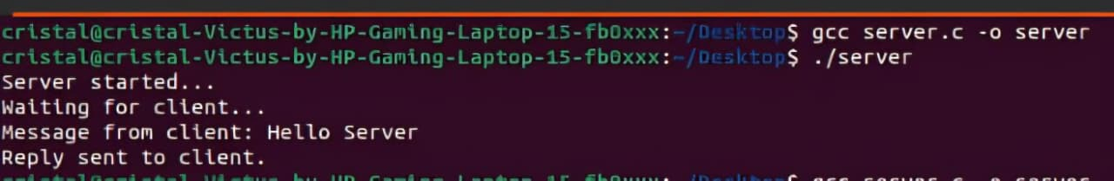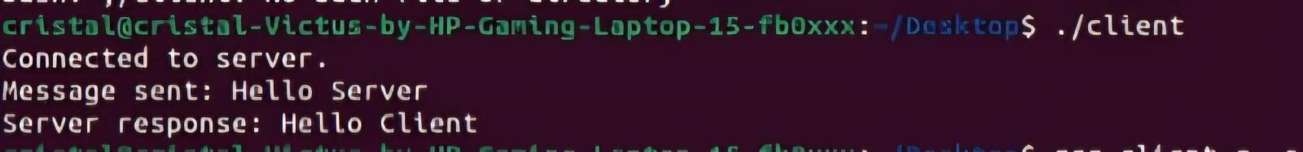

Question 2 – Arithmetic Server
SERVER
#include <stdio.h>
#include <winsock2.h>

#define PORT 8080

int main()
{
WSADATA wsa;
SOCKET serverSocket, clientSocket;
struct sockaddr_in serverAddr, clientAddr;
int addrSize;

int a, b;
int sum, difference, product;
float division;

// Initialize Winsock
WSAStartup(MAKEWORD(2, 2), &wsa);

// Create socket
serverSocket = socket(AF_INET, SOCK_STREAM, 0);

// Server address
serverAddr.sin_family = AF_INET;
serverAddr.sin_addr.s_addr = INADDR_ANY;
serverAddr.sin_port = htons(PORT);

// Bind
bind(serverSocket, (struct sockaddr *)&serverAddr,
sizeof(serverAddr));

// Listen
listen(serverSocket, 5);

printf("Server is waiting for connection...\n");

// Accept client
addrSize = sizeof(clientAddr);

clientSocket = accept(serverSocket,
(struct sockaddr *)&clientAddr,
&addrSize);

// Receive two integers
recv(clientSocket, (char *)&a, sizeof(a), 0);
recv(clientSocket, (char *)&b, sizeof(b), 0);

// Perform calculations
sum = a + b;
difference = a - b;
product = a * b;

if (b != 0)
division = (float)a / b;
else
division = 0;

// Send results
send(clientSocket, (char *)&sum, sizeof(sum), 0);
send(clientSocket, (char *)&difference, sizeof(difference), 0);
send(clientSocket, (char *)&product, sizeof(product), 0);
send(clientSocket, (char *)&division, sizeof(division), 0);

closesocket(clientSocket);
closesocket(serverSocket);

WSACleanup();

return 0;
}
CLIENT

#include <stdio.h>
#include <winsock2.h>

#define PORT 8080

int main()
{
WSADATA wsa;
SOCKET clientSocket;
struct sockaddr_in serverAddr;
int a, b;
int sum, difference, product;
float division;
WSAStartup(MAKEWORD(2, 2), &wsa);
clientSocket = socket(AF_INET, SOCK_STREAM, 0);
// Server address
serverAddr.sin_family = AF_INET;
serverAddr.sin_port = htons(PORT);
serverAddr.sin_addr.s_addr = inet_addr("127.0.0.1");
// Connect to server
connect(clientSocket,
(struct sockaddr *)&serverAddr,
sizeof(serverAddr));
// Input
printf("Enter two integers: ");
scanf("%d %d", &a, &b);

// Send integers
send(clientSocket, (char *)&a, sizeof(a), 0);
send(clientSocket, (char *)&b, sizeof(b), 0);

// Receive results
recv(clientSocket, (char *)&sum, sizeof(sum), 0);
recv(clientSocket, (char *)&difference, sizeof(difference), 0);
recv(clientSocket, (char *)&product, sizeof(product), 0);
recv(clientSocket, (char *)&division, sizeof(division), 0);

// Display results
printf("\nAddition = %d\n", sum);
printf("Subtraction = %d\n", difference);
printf("Multiplication = %d\n", product);

if (b != 0)
printf("Division = %.2f\n", division);
else
printf("Division = Cannot divide by zero\n");
closesocket(clientSocket);

WSACleanup();

return 0;
}

OUTPUT
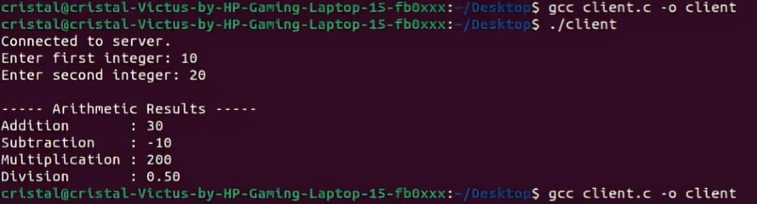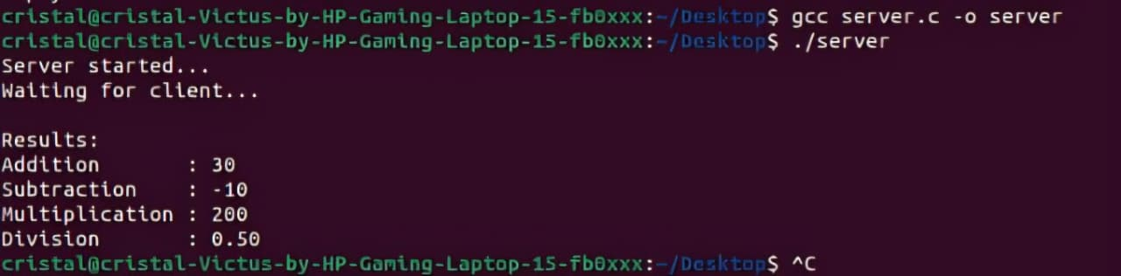

Question 3 – String Processing Server

SERVER
#include <stdio.h>
#include <string.h>
#include <ctype.h>
#include <winsock2.h>
#define PORT 8080
int main()
{
WSADATA wsa;
SOCKET serverSocket, clientSocket;
struct sockaddr_in serverAddr, clientAddr;
int addrSize;
char str[1024];
char uppercase[1024];
char reverse[1024];
int length;
int i;
WSAStartup(MAKEWORD(2, 2), &wsa);
serverSocket = socket(AF_INET, SOCK_STREAM, 0);
serverAddr.sin_family = AF_INET;
serverAddr.sin_addr.s_addr = INADDR_ANY;
serverAddr.sin_port = htons(PORT);
bind(serverSocket, (struct sockaddr *)&serverAddr,
sizeof(serverAddr));
listen(serverSocket, 5);
printf("Server is waiting for connection...\n");
addrSize = sizeof(clientAddr);
clientSocket = accept(serverSocket,
(struct sockaddr *)&clientAddr,
&addrSize);
recv(clientSocket, str, sizeof(str), 0);
length = strlen(str);
for (i = 0; i < length; i++)
{
uppercase[i] = toupper((unsigned char)str[i]);
}
uppercase[length] = '\0';
for (i = 0; i < length; i++)
{
reverse[i] = str[length - 1 - i];
}
reverse[length] = '\0';
send(clientSocket, (char *)&length, sizeof(length), 0);
send(clientSocket, uppercase, sizeof(uppercase), 0);
send(clientSocket, reverse, sizeof(reverse), 0);
closesocket(clientSocket);
closesocket(serverSocket);
WSACleanup();
return 0;
}
CLIENT
#include <stdio.h>
#include <string.h>
#include <winsock2.h>
#define PORT 8080
int main()
{
WSADATA wsa;
SOCKET clientSocket;
struct sockaddr_in serverAddr;
char str[1024];
char uppercase[1024];
char reverse[1024];
int length;

// Initialize Winsock
WSAStartup(MAKEWORD(2, 2), &wsa);
// Create socket
clientSocket = socket(AF_INET, SOCK_STREAM, 0);
// Server address
serverAddr.sin_family = AF_INET;
serverAddr.sin_port = htons(PORT);
serverAddr.sin_addr.s_addr = inet_addr("127.0.0.1");
// Connect to server
connect(clientSocket,
(struct sockaddr *)&serverAddr,
sizeof(serverAddr));
// Input string
printf("Enter a string: ");
fgets(str, sizeof(str), stdin);
// Remove newline
str[strcspn(str, "\n")] = '\0';
// Send string
send(clientSocket, str, sizeof(str), 0);
// Receive results
recv(clientSocket, (char *)&length, sizeof(length), 0);
recv(clientSocket, uppercase, sizeof(uppercase), 0);
recv(clientSocket, reverse, sizeof(reverse), 0);
// Display results
printf("\nLength = %d\n", length);
printf("Uppercase = %s\n", uppercase);
printf("Reverse = %s\n", reverse);

closesocket(clientSocket);
WSACleanup();
return 0;
}

OUTPUT
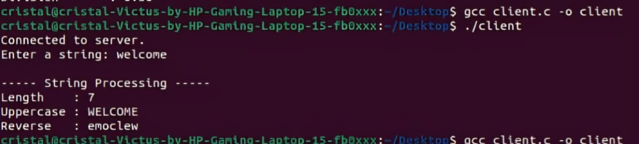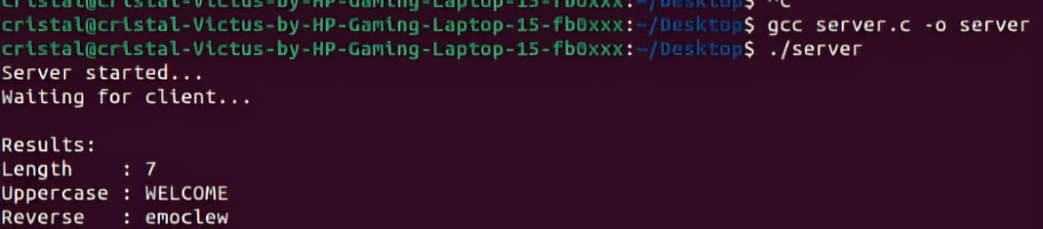

Question 4 – Array Processing Server
SERVER
#include <stdio.h>
#include <unistd.h>
#include <arpa/inet.h>

struct Result {
int sum;
float average;
int maximum;
int minimum;
};

int main() {
int server_fd, client_fd;
int n;
int arr[100];
struct Result result;

struct sockaddr_in server, client;
socklen_t addr_size = sizeof(client);

server_fd = socket(AF_INET, SOCK_STREAM, 0);

server.sin_family = AF_INET;
server.sin_addr.s_addr = INADDR_ANY;
server.sin_port = htons(8080);

bind(server_fd, (struct sockaddr*)&server, sizeof(server));
listen(server_fd, 5);

printf("Server waiting...\n");

client_fd = accept(server_fd,
(struct sockaddr*)&client,
&addr_size);

recv(client_fd, &n, sizeof(n), 0);
recv(client_fd, arr, sizeof(arr), 0);

result.sum = 0;
result.maximum = arr[0];
result.minimum = arr[0];

for (int i = 0; i < n; i++) {
result.sum += arr[i];

if (arr[i] > result.maximum)
result.maximum = arr[i];

if (arr[i] < result.minimum)
result.minimum = arr[i];
}

result.average = (float)result.sum / n;

send(client_fd, &result, sizeof(result), 0);

close(client_fd);
close(server_fd);

return 0;
}

CLIENT
#include <stdio.h>
#include <unistd.h>
#include <arpa/inet.h>

struct Result {
int sum;
float average;
int maximum;
int minimum;
};

int main() {
int sock;
int n;
int arr[100];
struct Result result;

struct sockaddr_in server;

sock = socket(AF_INET, SOCK_STREAM, 0);

server.sin_family = AF_INET;
server.sin_port = htons(8080);
server.sin_addr.s_addr = inet_addr("127.0.0.1");

connect(sock, (struct sockaddr*)&server, sizeof(server));

printf("Enter number of elements: ");
scanf("%d", &n);

printf("Enter %d integers:\n", n);

for (int i = 0; i < n; i++)
scanf("%d", &arr[i]);

send(sock, &n, sizeof(n), 0);
send(sock, arr, sizeof(arr), 0);
recv(sock, &result, sizeof(result), 0);
printf("\nSum = %d\n", result.sum);
printf("Average = %.2f\n", result.average);
printf("Maximum = %d\n", result.maximum);
printf("Minimum = %d\n", result.minimum);
close(sock);
return 0;
}

OUTPUT

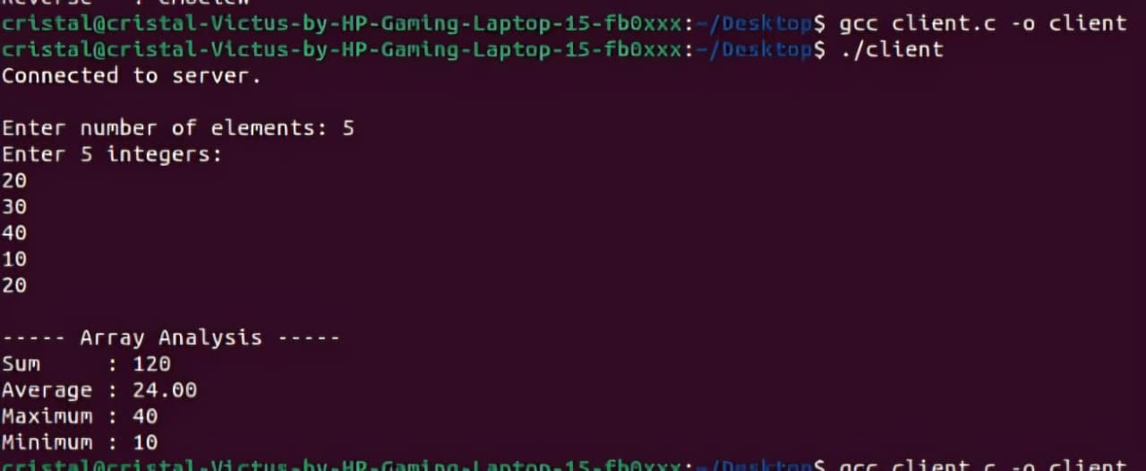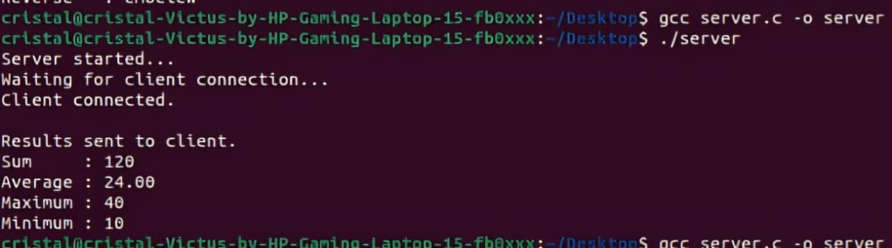

Question 5 – Matrix Analyzer

SERVER
#include <stdio.h>
#include <string.h>
#include <unistd.h>
#include <arpa/inet.h>

struct Result {
char type[50];
int sum;
int trace;
};

int main() {
int server_fd, client_fd;
int n;
int matrix[20][20];
struct Result result;

int upper = 1;
int lower = 1;
int diagonal = 1;

struct sockaddr_in server, client;
socklen_t addr_size = sizeof(client);

server_fd = socket(AF_INET, SOCK_STREAM, 0);

server.sin_family = AF_INET;
server.sin_addr.s_addr = INADDR_ANY;
server.sin_port = htons(8080);

bind(server_fd, (struct sockaddr*)&server, sizeof(server));
listen(server_fd, 5);

printf("Server waiting...\n");

client_fd = accept(server_fd,
(struct sockaddr*)&client,
&addr_size);

recv(client_fd, &n, sizeof(n), 0);
recv(client_fd, matrix, sizeof(matrix), 0);

result.sum = 0;
result.trace = 0;

for (int i = 0; i < n; i++) {
for (int j = 0; j < n; j++) {

result.sum += matrix[i][j];

if (i == j)
result.trace += matrix[i][j];

if (i > j && matrix[i][j] != 0)
upper = 0;

if (i < j && matrix[i][j] != 0)
lower = 0;

if (i != j && matrix[i][j] != 0)
diagonal = 0;
}
}

if (diagonal)
strcpy(result.type, "Diagonal Matrix");
else if (upper)
strcpy(result.type, "Upper Triangular Matrix");
else if (lower)
strcpy(result.type, "Lower Triangular Matrix");
else
strcpy(result.type, "General Matrix");

send(client_fd, &result, sizeof(result), 0);

close(client_fd);
close(server_fd);

return 0;
}

CLIENT

#include <stdio.h>
#include <unistd.h>
#include <arpa/inet.h>

struct Result {
char type[50];
int sum;
int trace;
};

int main() {
int sock;
int n;
int matrix[20][20];
struct Result result;

struct sockaddr_in server;

sock = socket(AF_INET, SOCK_STREAM, 0);

server.sin_family = AF_INET;
server.sin_port = htons(8080);
server.sin_addr.s_addr = inet_addr("127.0.0.1");

connect(sock, (struct sockaddr*)&server, sizeof(server));

printf("Enter order of square matrix: ");
scanf("%d", &n);

printf("Enter matrix elements:\n");

for (int i = 0; i < n; i++) {
for (int j = 0; j < n; j++) {
scanf("%d", &matrix[i][j]);
}
}

send(sock, &n, sizeof(n), 0);
send(sock, matrix, sizeof(matrix), 0);

recv(sock, &result, sizeof(result), 0);

printf("\nMatrix Type = %s\n", result.type);
printf("Sum = %d\n", result.sum);
printf("Trace = %d\n", result.trace);

close(sock);
return 0;
}
OUTPUT
